

**Malignant Comments Classifier Prediction**

**Project**

Submitted by:

Femina Aneesh

**ACKNOWLEDGMENT**

I would like to express my special thanks of gratitude to all the teachers who have taught me Machine Learning and NLP. Because of the knowledge they had provided to me I am able to complete this project.

I have referred the below links for referring the projects.

1. [www.google.com](http://www.google.com)
2. [www.analyticsvidya.com](http://www.analyticsvidya.com)

**INTRODUCTION**

* **Business Problem Framing**

The proliferation of social media enables people to express their opinions widely online. However, at the same time, this has resulted in the emergence of conflict and hate, making online environments uninviting for users. Although researchers have found that hate is a problem across multiple platforms, there is a lack of models for online hate detection.

Online hate, described as abusive language, aggression, cyberbullying, hatefulness and many others has been identified as a major threat on online social media platforms. Social media platforms are the most prominent grounds for such toxic behaviour. There has been a remarkable increase in the cases of cyberbullying and trolls on various social media platforms.

Many celebrities and influences are facing backlashes from people and have to come across hateful and offensive comments. This can take a toll on anyone and affect them mentally leading to depression, mental illness, self-hatred and suicidal thoughts.

Internet comments are bastions of hatred and vitriol. While online anonymity has provided a new outlet for aggression and hate speech, machine learning can be used to fight it. The problem we sought to solve was the tagging of internet comments that are aggressive towards other users. This means that insults to third parties such as celebrities will be tagged as unoffensive, but “u are an idiot” is clearly offensive.

Our goal is to build a prototype of online hate and abuse comment classifier which can used to classify hate and offensive comments so that it can be controlled and restricted from spreading hatred and cyberbullying.

* **Conceptual Background of the Domain Problem**

In the past few years its seen that the cases related to social media hatred have increased exponentially. The social media is turning into a dark venomous pit for people now a days. Online hate is the result of difference in opinion, race, religion, occupation, nationality etc. In social media the people spreading or involved in such kind of activities uses filthy languages, aggression, images etc. to offend and gravely hurt the person on the other side. This is one of the major concerns now. The result of such activities can be dangerous. It gives mental trauma to the victims making their lives miserable. People who are not well aware of mental health online hate or cyber bullying become life threatening for them. Such cases are also at rise. It is also taking its toll on religions. Each and every day we can see an incident of fighting between people of different communities or religions due to offensive social media posts. Online hate, described as abusive language, aggression, cyberbullying, hatefulness, insults, personal attacks, provocation, racism, sexism, threats, or toxicity has been identified as a major threat on online social media platforms. These kinds of activities must be checked for a better future.

* **Review of Literature**

Aggression by text is a complex phenomenon, and different knowledge fields try to study and tackle this problem. This analysis of related work focuses on a computer science perspective of aggression identification, a recent emerging area. Currently, the scientific study of automatic identification of aggressive text, using information technology techniques, is increasing. In this study, several related literature are used to express different types of aggression. Some of those are hate , cyber bullying (, abusive language , toxicity.

* Motivation for the Problem Undertaken

The project was the first provided to me by FlipRobo as a part of the internship programme. The exposure to real world data and the opportunity to deploy my skillset in solving a real time problem has been the primary objective. However, the motivation for taking this project was that it is relatively a new field of research. Here we have many options but less concrete solutions. The main motivation is to build a prototype of online hate and abuse comment classifier which can used to classify hate and offensive comments so that it can be controlled and restricted from spreading hatred and cyberbullying.

**Analytical Problem Framing**

* Mathematical/ Analytical Modeling of the Problem
* Project contain train and test dataset as well.
* In train data set there are 159,571 rows and 8 columns.
* There are no null values in the dataset
* Most of the data are numeric in nature which are binary.
* Comments is object in nature and consist of text
* Data Sources and their formats

The data was provided by FlipRobo in CSV format. After loading the training dataset into Jupyter Notebook using Pandas and it can be seen that there are eight columns named as: “ id, comment_text, “malignant, highly_malignant, rude, threat, abuse, loathe”. There are 8 columns in the dataset provided: The description of each of the column is given below: Malignant: It is the Label column, which includes values 0 and 1, denoting if the comment is malignant or not. Highly Malignant: It denotes comments that are highly malignant and hurtful. Rude: It denotes comments that are very rude and offensive. Threat: It contains indication of the comments that are giving any threat to someone. Abuse: It is for comments that are abusive in nature. Loathe: It describes the comments which are hateful and loathing in nature. ID: It includes unique Ids associated with each comment text given. Comment text: This column contains the comments extracted from various social media platforms.

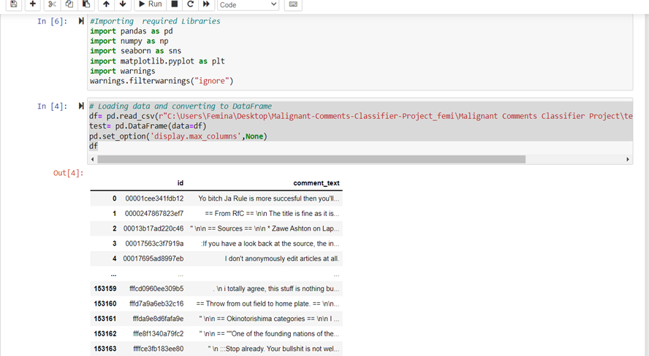

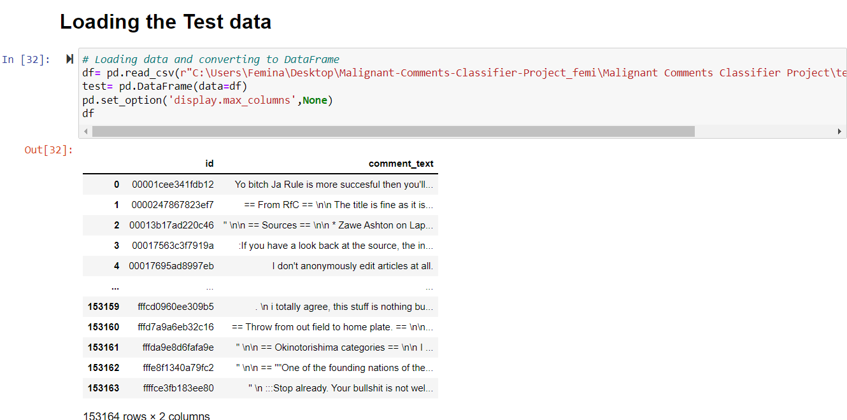

* Data Preprocessing Done

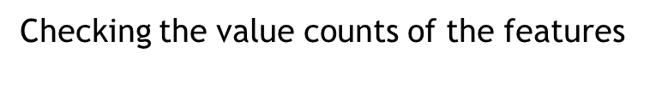

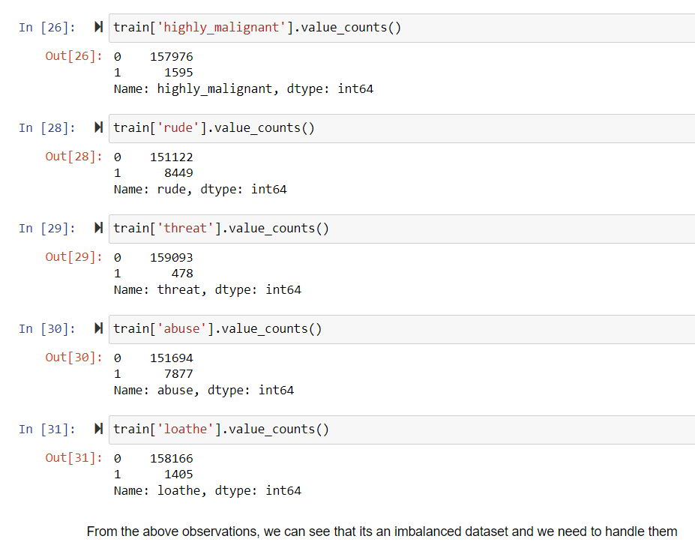

Checking for null values

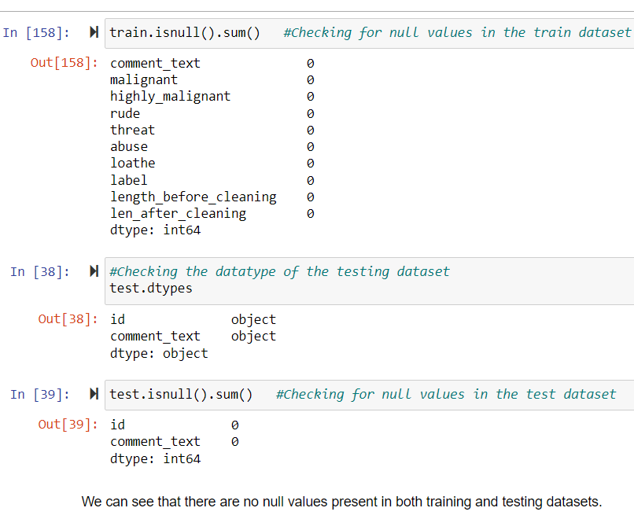

**Checking statistical summary of the dataset**

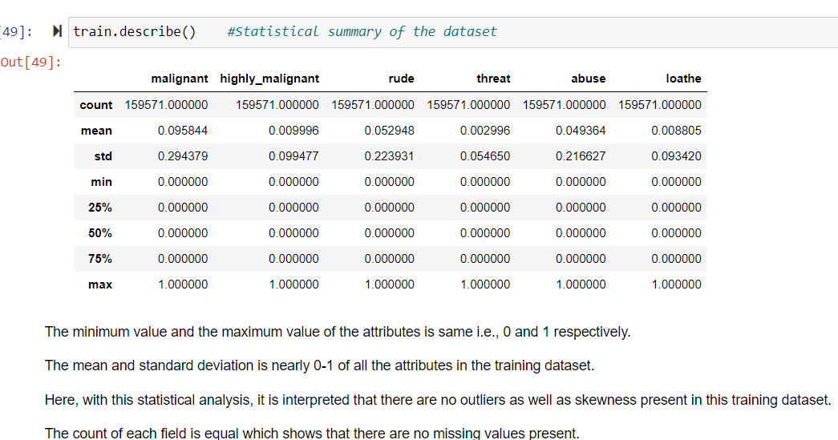

Finding relationship among data using correlation

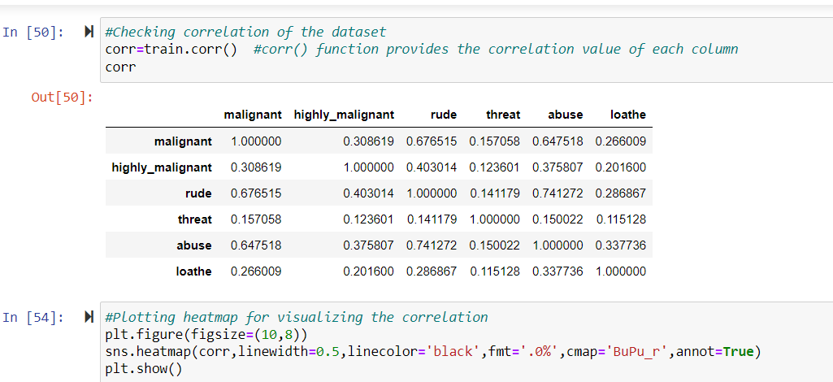

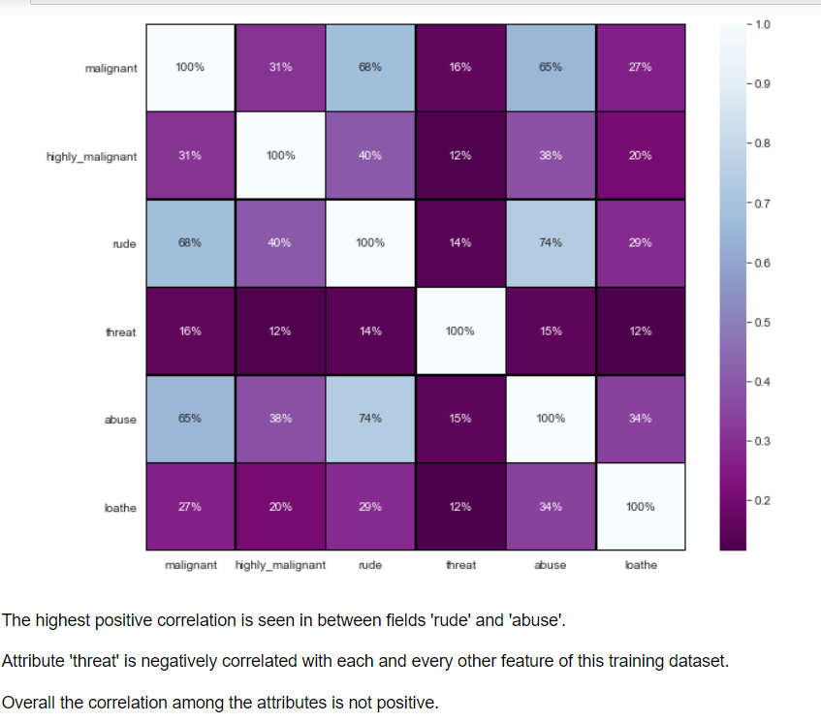

* Data Inputs- Logic- Output Relationships

There are features which are highly correlated. It is possible because one comment can be classified into multip le categories. One comment can be rude and abuse at same time. Most of the text length are within 500 characters, with some up to 5,000 characters long.

**Dropping the Column**   
Due to the wide range of given data, it is extremely fruitful to clean, shape and set the data in the most suitable form. Dropping unnecessary columns declines the chances of producing errors. Thus, column ‘ID’ was dropped from the train dataset as every comment has its own unique id. After dropping the same, the dataset is now having 7 attributes in total including the target variables.

**Cleaning the Data using NLP**

Data cleaning is the process of preparing data fo analysis by removing or modifying data that is incorrect,incomplete, irrelevant, duplicated, or improperly formatted.This data is usually not necessary or helpful when it comes to analysing data because it may hinder the process or provide inaccurate results.

Before cleaning the data, a new column is created named ‘length_before_cleaning’ which shows the total length of the comments respectively before cleaning the text.

* Replaced the extra lines or ‘\n’ from the text.
* Transform the text into lower case.
* Replaced the email addresses with the text 'emailaddress'
* Replaced the URLs with the text 'webaddress'
* Removed the numbers
* Removed the HTML tags
* Removed the punctuations
* Removed all the non-ascii characters
* Removed the unwanted white spaces
* Removed the remaining tokens that are not alphabetic
* Removed the stop words

The code for the above mentioned steps is:

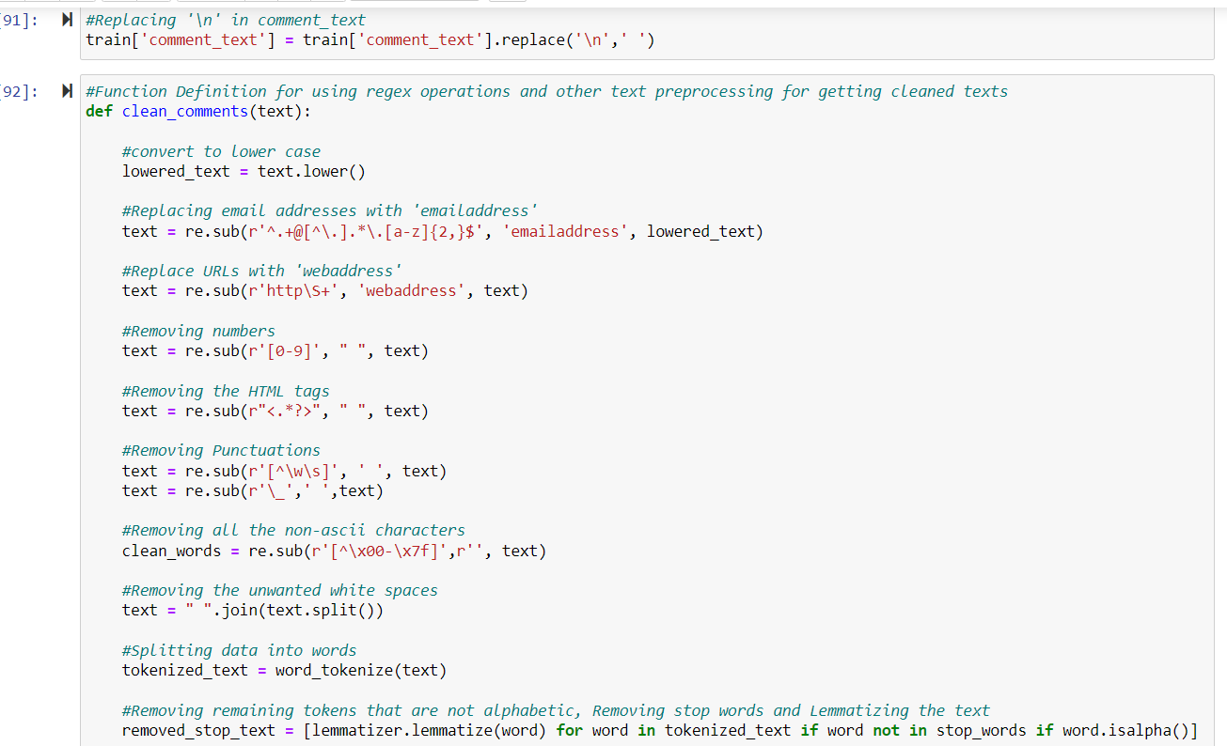

All the text cleaning or the above steps are peformed by defining a function and applying the same using apply() to the comment_text column of the train dataset.

**Tokenization**

Word tokenization is the process of splitting a large sample of text into words.This is a requirement in natural language processing tasks where each word needs to be captured and subjected to further analysis.

After cleaning the text,each comment i.e, the corpus is split into words.Thus, the text is tokenized into words using word_tokenize().

**Lemmatization**

Lemmatization in NLTK refers to the morphological analysis of words,which aims to remove inflectional endings.It helps in returning the base or dictionary form of a word known as the lemma.

The NLTK Lemmatization method is based on WorldNet’s built-in morph function.Thus , the words are lemmatized using WordNetLemmatizer() after importing the necessary library to perform the same and then creating the instance for it.

After cleaning the text, a new column is created named ‘len_after_cleaning’ representing the length of each comment respectively in a column ‘comment_text’after doing the required cleaning of the text.With this,it’s come to know about how much data is cleaned.

**Plotting wordcloud for each feature**

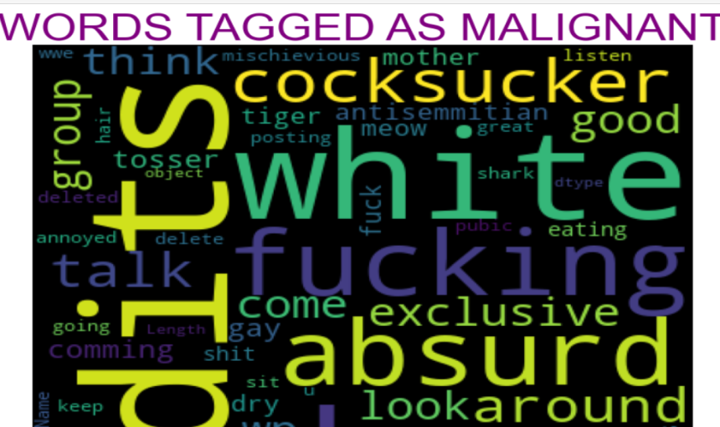 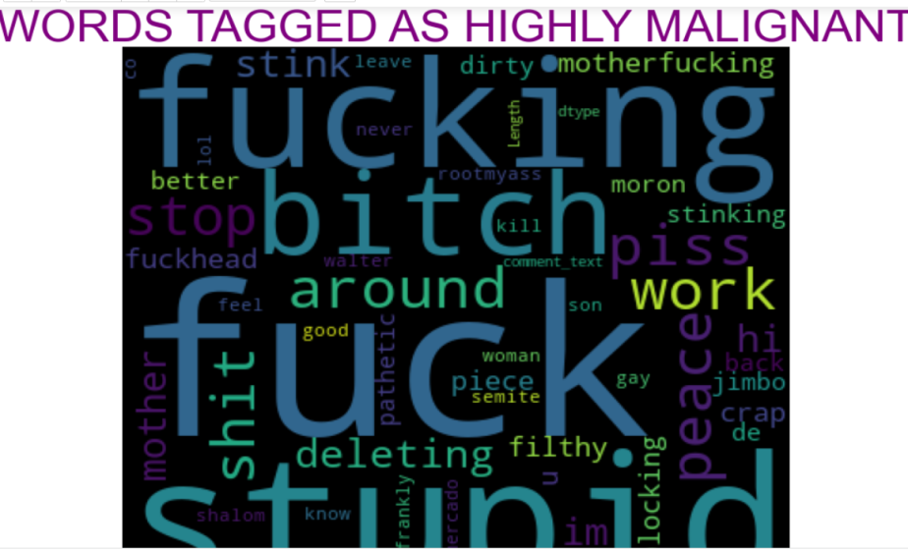

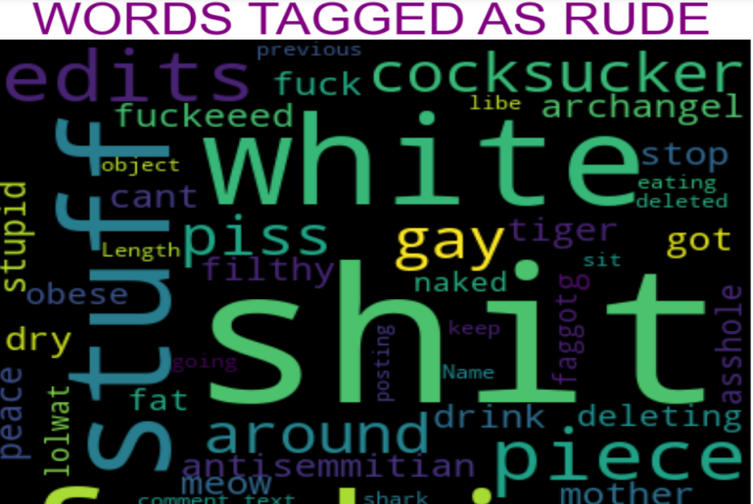 

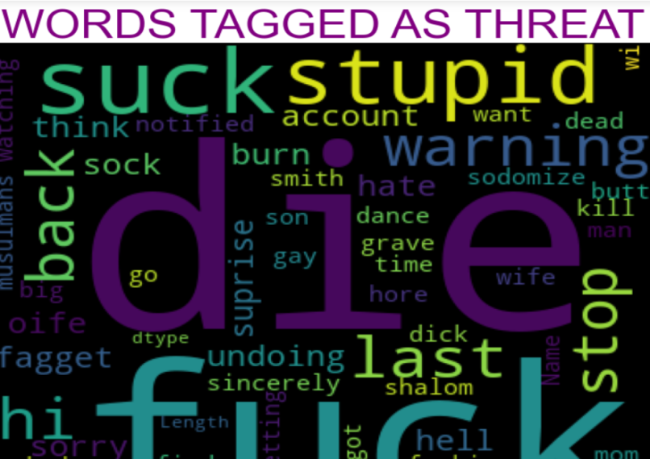

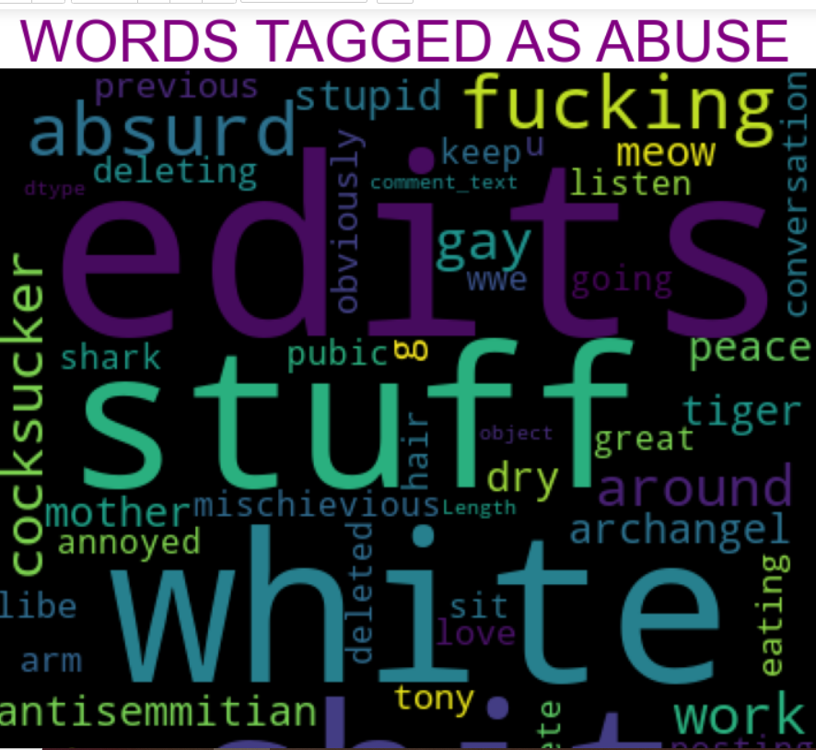

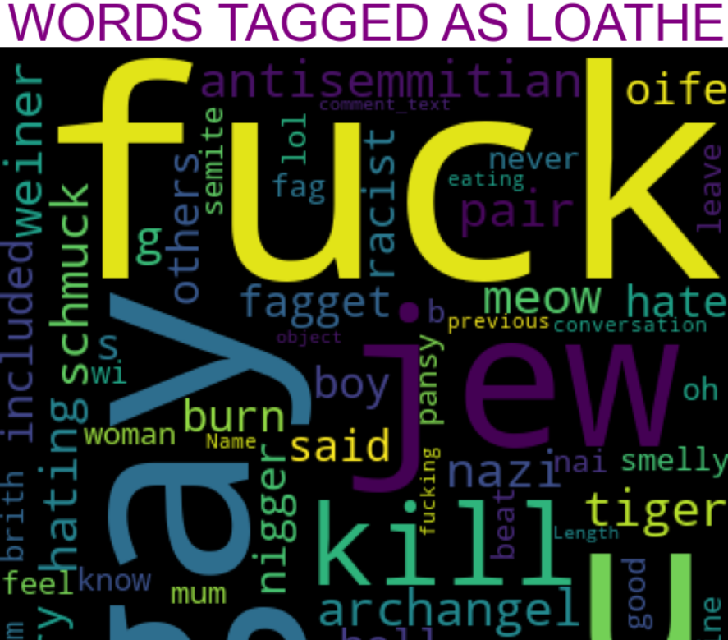

From the above wordclouds, we can see that the large texts have more weightage in their respective type of comments whereas small texts have the lesser weightages.

Hardware and Software Requirements and Tools Used

* For dping this project,the hardware used is a laptop with high end specification and a stable internet connection.While coming to software part,I had used anaconda navigator and in that I have used Jupyter notebook to do my python programming and analysis.
* For using a CSV file, Microsoft excel is needed.In Jupyter notebook, I had used lots of python libraries to carry out this project.

**Model/s Development and Evaluation**

* Identification of possible problem-solving approaches (methods)

Read the use case and search from the google to know more about the use case and in which field or domain it will applicable more. As data set is already there, so this step is excluded. Data Preparation includes the data cleaning and describing the data which I followed text pre-processing. EDA involves the visualization which is helpful to get more insight from the data and get to know about the mostly use comment and check the most frequent words. Modelling involves creating the model with suitable algorithm which provide the best result, I tried multiple algo and apply hyperparameter tuning. Model Evaluation, for this I used confusion metrices and mainly focus on False negative and tried to reduce the False negative which is type 2 error and on F1 score as dataset is imbalance.

* Testing of Identified Approaches (Algorithms)
* LR=LogisticRegression()
* mnb=MultinomialNB()
* dtc=DecisionTreeClassifier()
* knc=KNeighborsClassifier()
* rfc=RandomForestClassifier()
* abc=AdaBoostClassifier()
* gbc=GradientBoostingClassifier()
* xgb=XGBClassifier().
* Run and Evaluate selected models

Separating independent and dependent features and converting the data into number features using Vectorizer



Splitting training and testing data, along with handling imbalanced dataset using RandomOverSampler

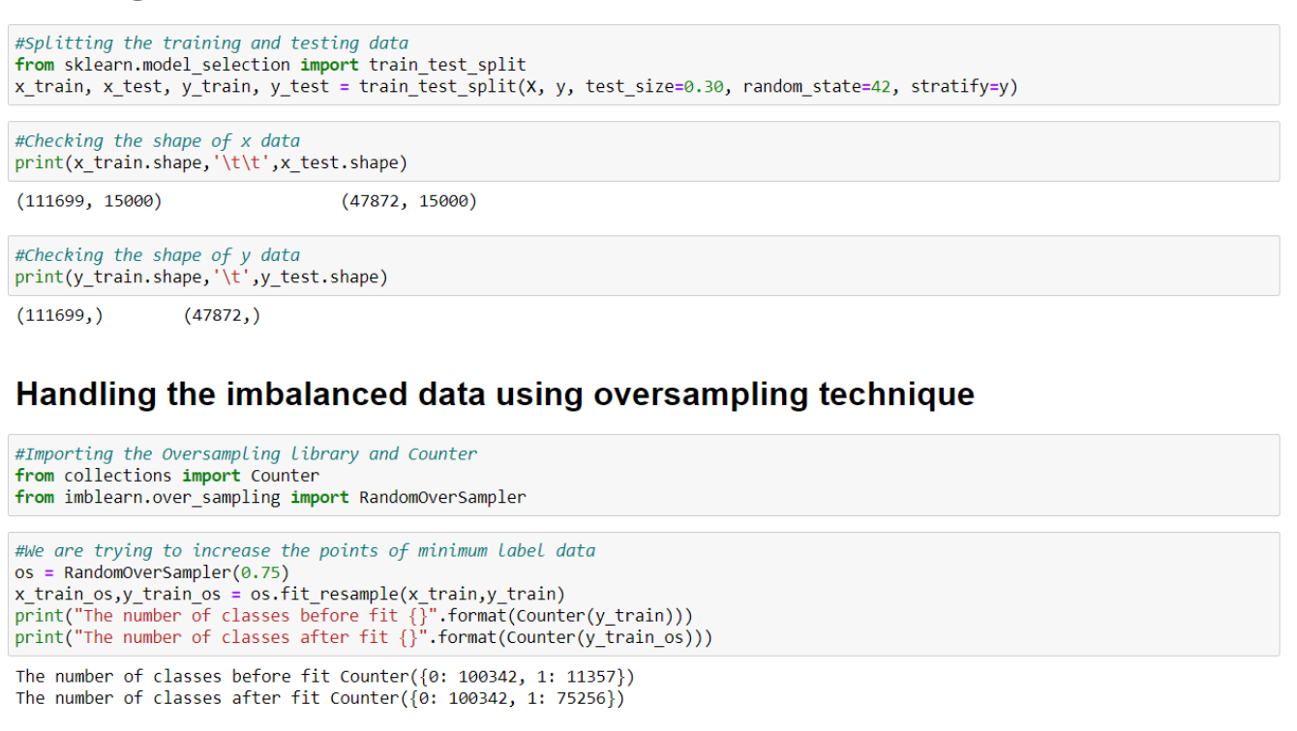

Building the model

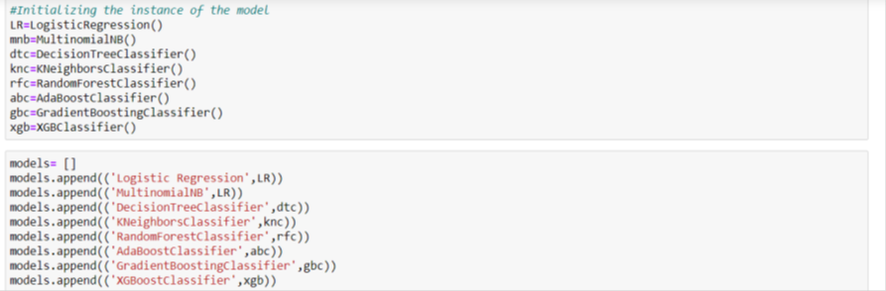

* 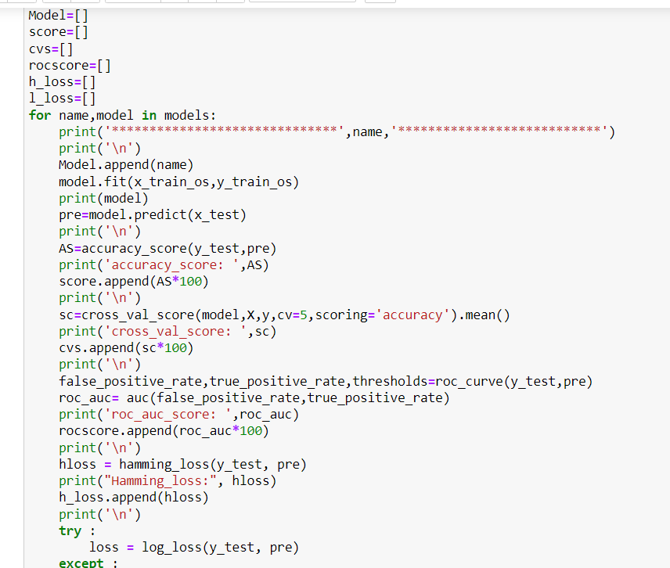

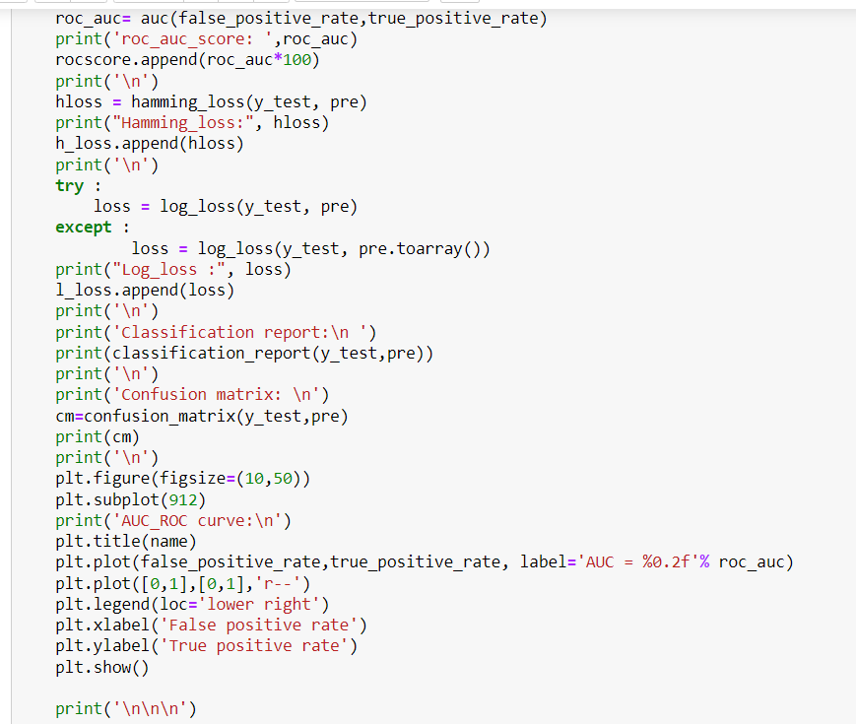

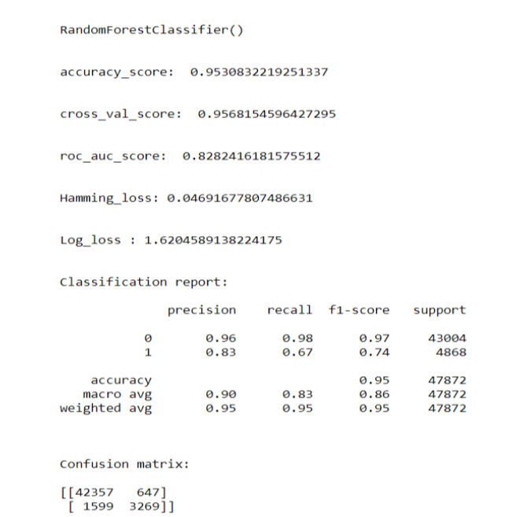

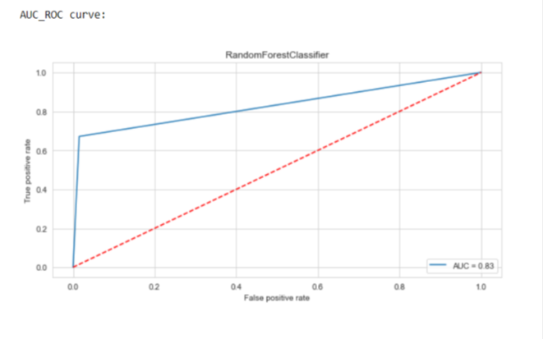

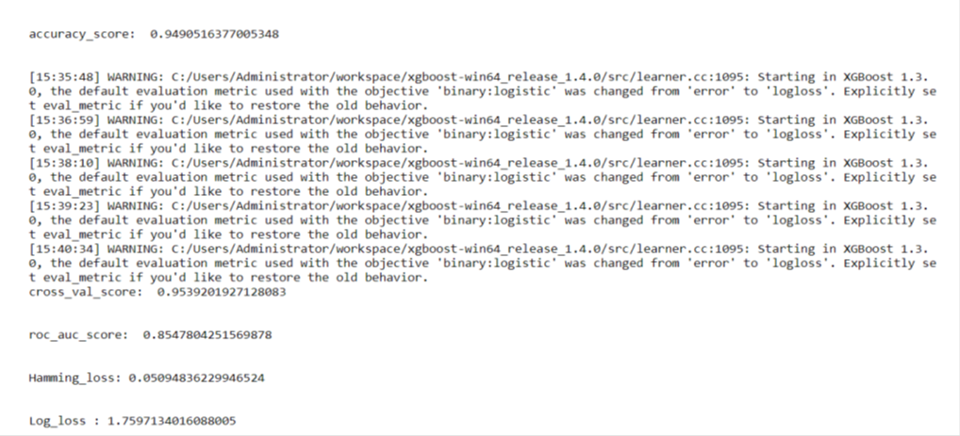

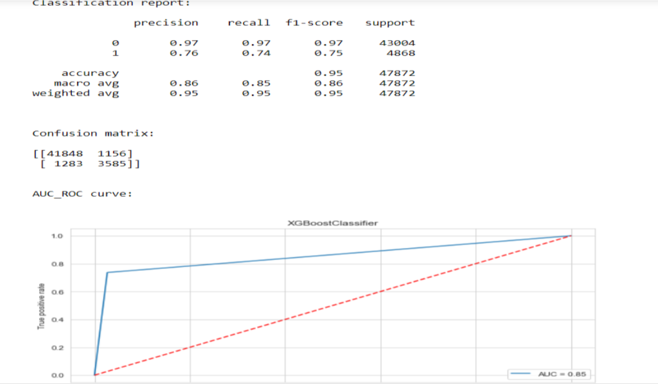

Final Result in a dataframe

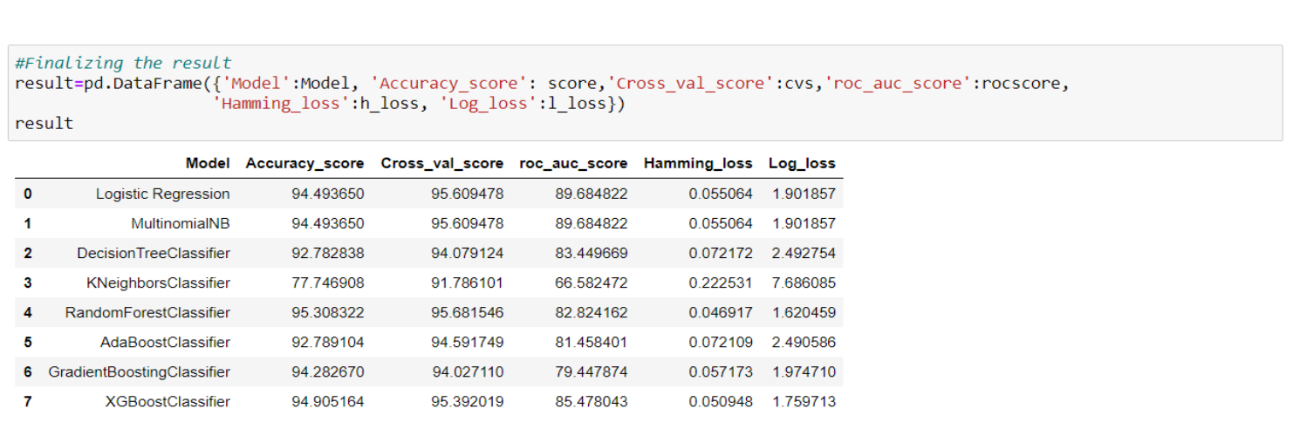

After running the for loop of classification algorithms and the required metrics, we can see that the best 2 performing algorithms are RandomForestClassifier and XGBoostClassifier because the loss values are less and their scores are the best among all. Now, we will try Hyperparameter Tuning to find out the best parameters and using them to improve the scores and metrics values.

**Hyperparameter Tuning**

If we run GridSearchCV and RandomSearchCV, it takes more than 2 hours to run the code as the dataset is huge and the best params are not obtained from it due to more computational power requirement. The AUC Score, f1-score and recall value is high when we use randomforest with over sampling data. So, we choose RandomForestClassifier model with over sampled data as our best model among all models.

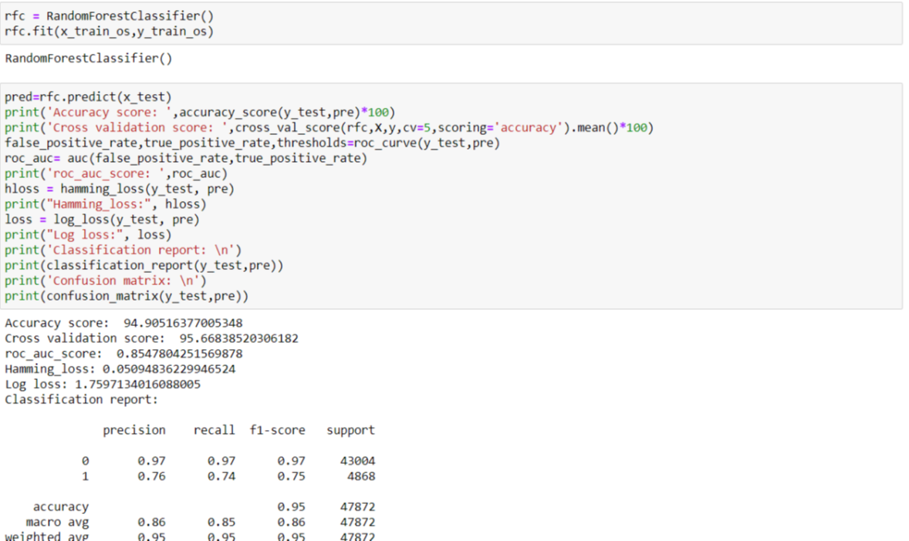

Plotting AUC_ROC Curve

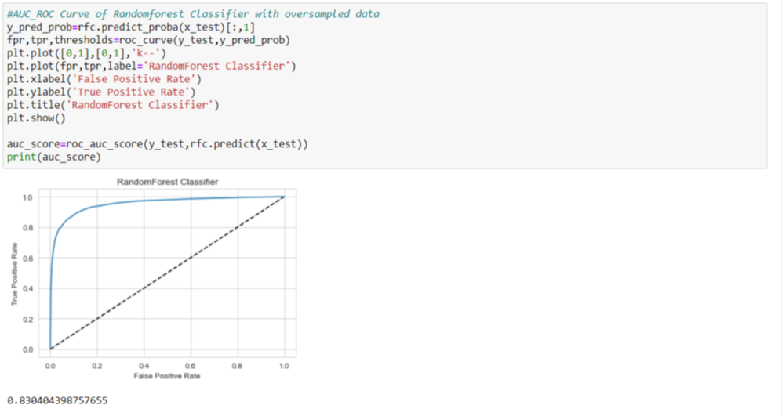

**Finalizing the model**

We will final the model by predicting the values and saving the model in a pickle file, which will be used for prediction of test data

**Predictions using test data**

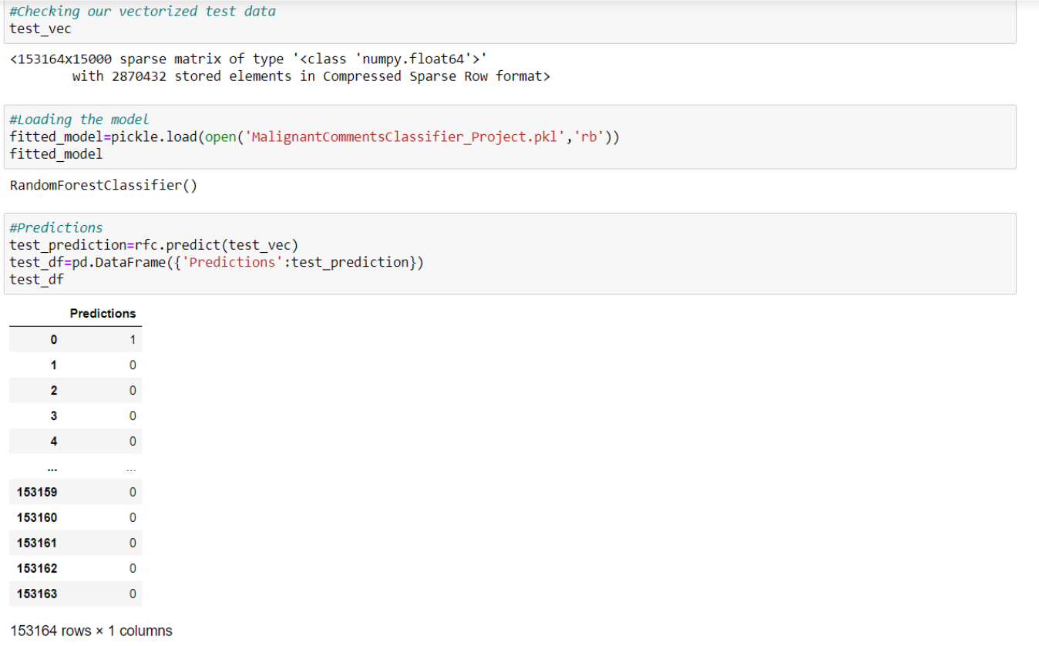

After predicting using test data, we will store the results in a csv file.

* Key Metrics for success in solving problem under consideration

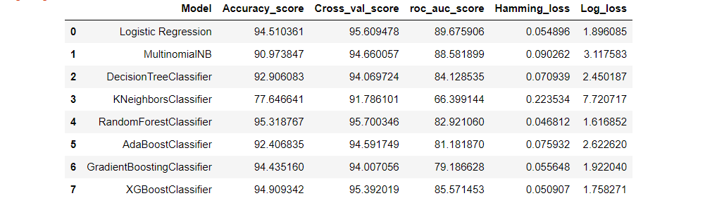

* **Data Visualizations**

Plotting countplot for all features

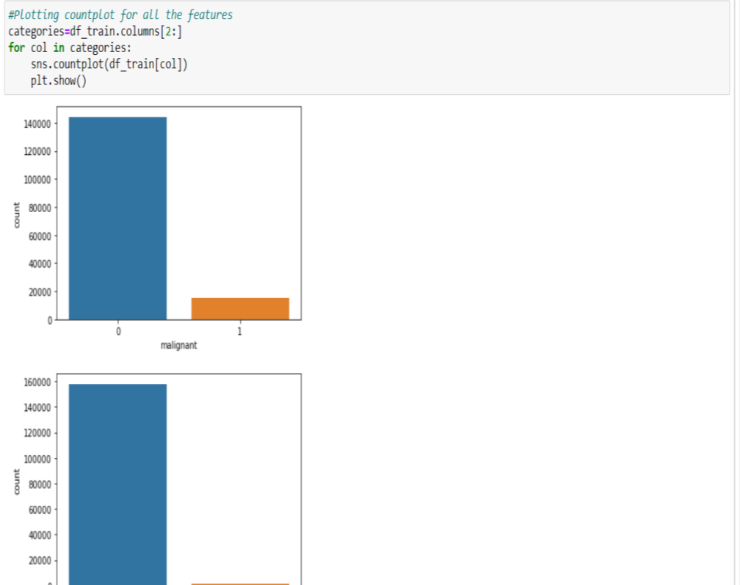

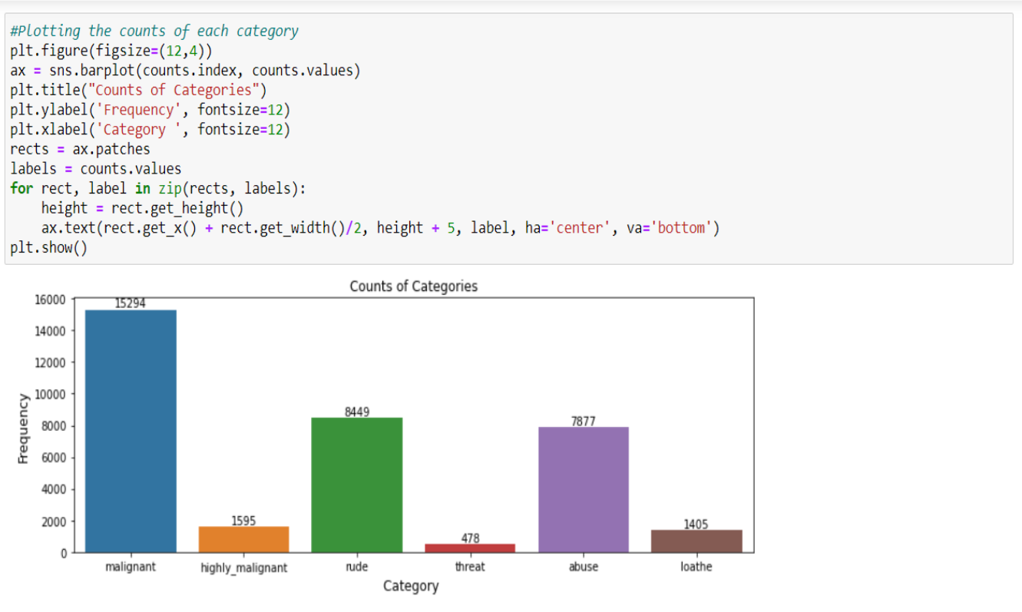

Plotting pie chart plot

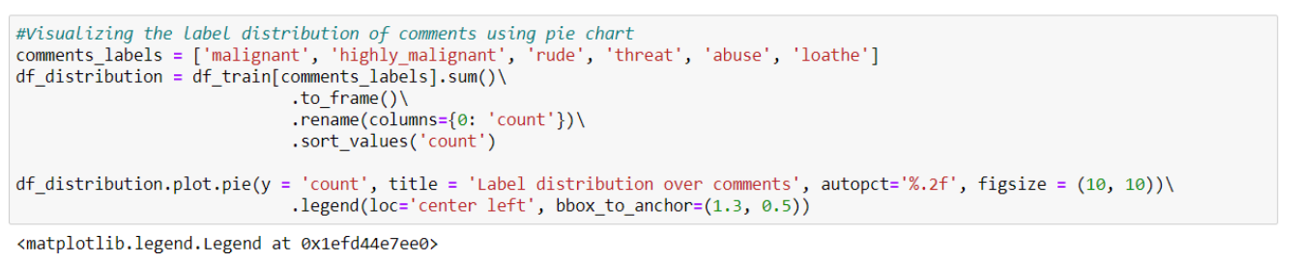

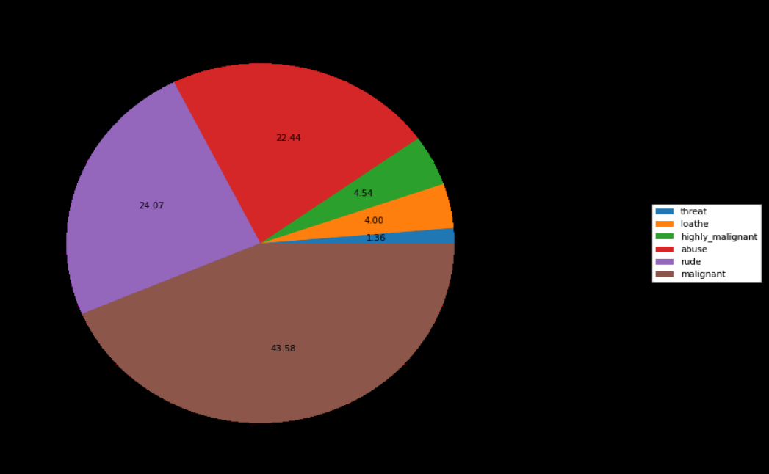

Distribution of comments length

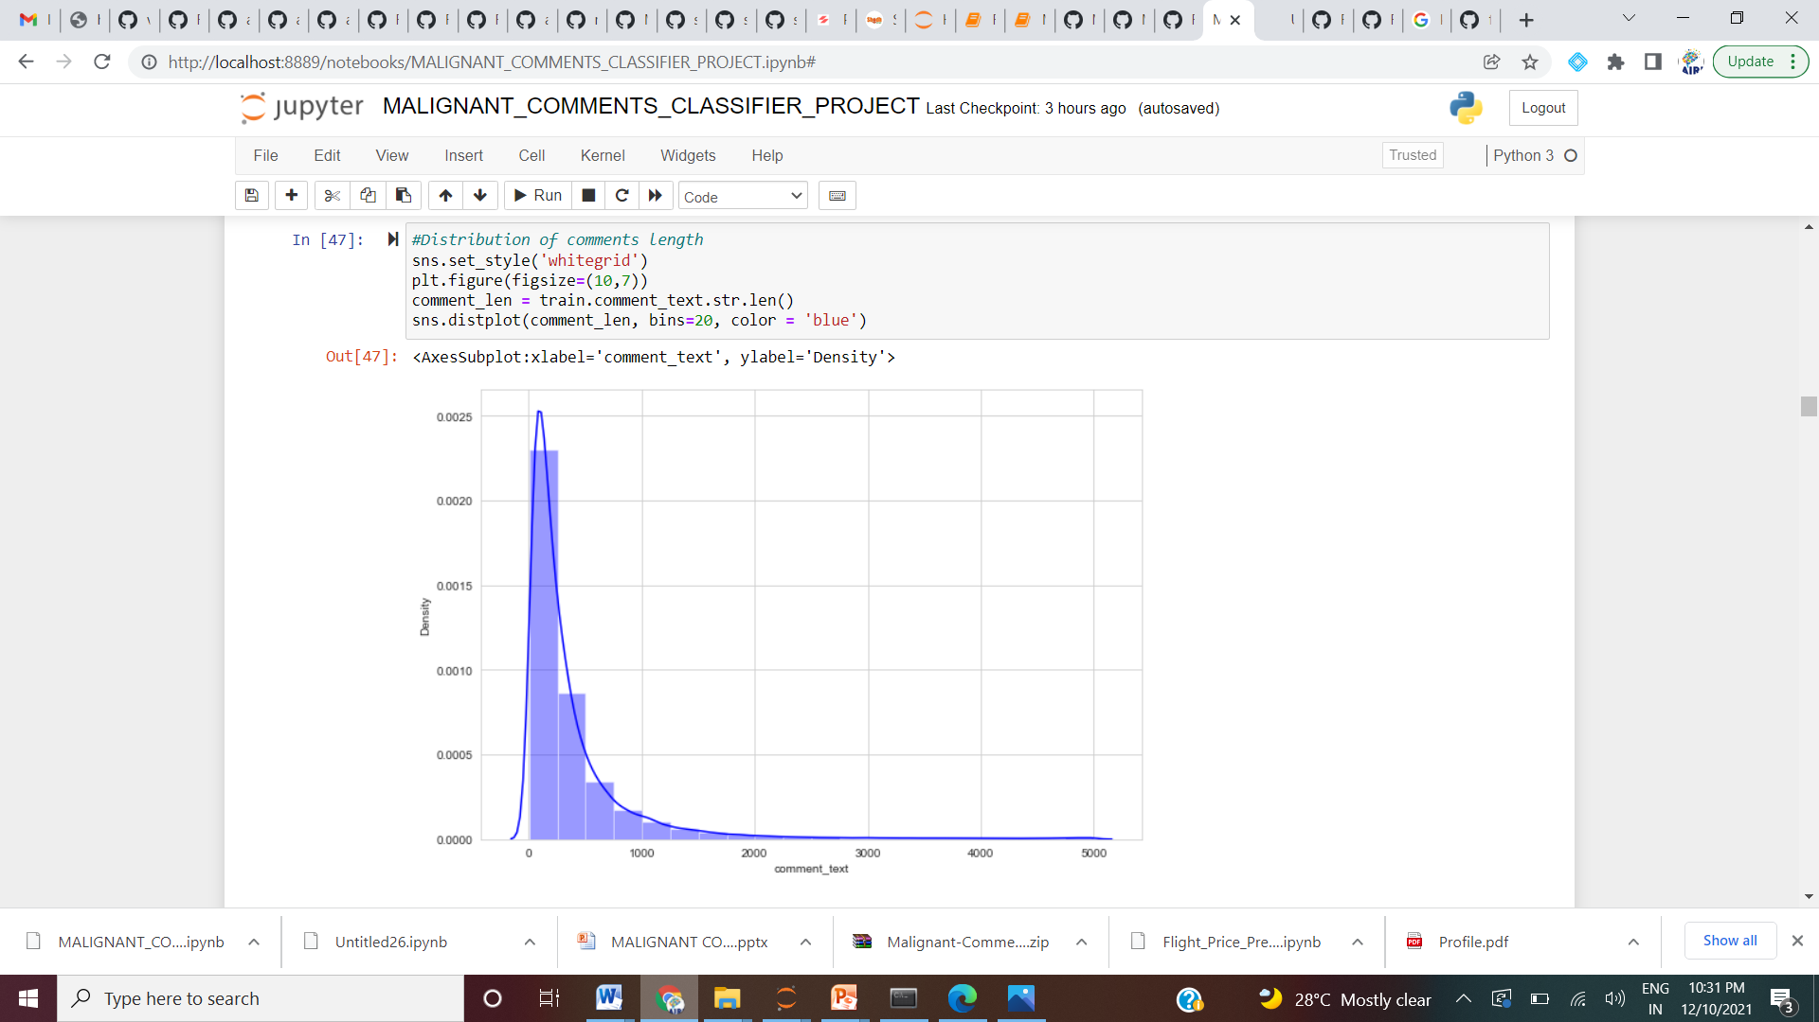

Above is a plot showing the comment length frequency. As noticed, most of the comments are short with only a few comments longer than 1000 words. Majority of the comments are of length 500, where maximum length is 5000 and minimum length is 5. Median length being 250.

Plotting distribution plot for all features

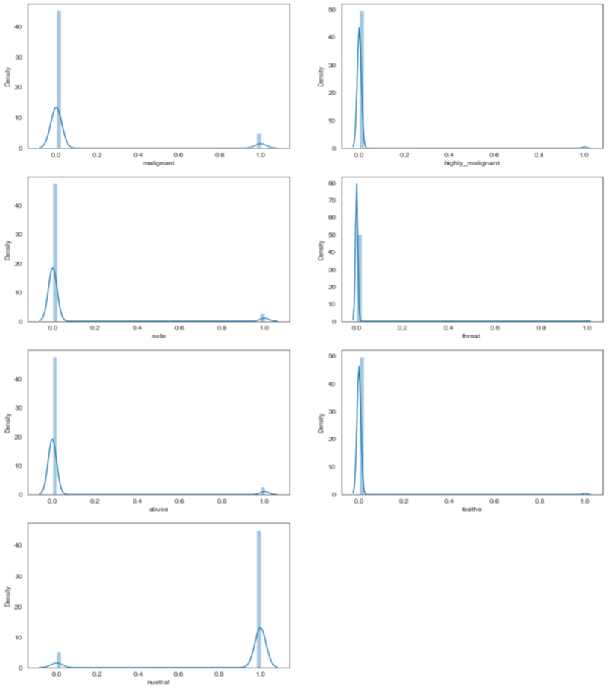

**CONCLUSION**

* After the completion of this project, we got an insight of how to preprocess the data, analysing the data and building a model.
* First, we imported both training and testing data, which had nearly 150000+ records.
* We did all the required pre-processing steps like checking null values, datatypes check, dropping unnecessary columns, etc.
* We used the training data for doing Exploratory Data Analysis using various plots and recorded the observations.
* While observing the results, we found that the dataset was in highly imbalanced side and we need to handle it, in order to avoid overfitting problem.
* Using NLP, we pre-processed the comment text and did other steps.
* As the problem was a multi-class classifier, we took a new feature known as label and combined the comment_labels output together using sum() and then stored in that feature. For a binary classification problem, we scaled the data accordingly.
* After applying Tf-idf Vectoriser, we used an oversampling technique called RandomOverSampler for handling the imbalanced data. There, we took 75% of the high points data and sampled it to the low points data so that both weights could be balanced equally and we could get proper result. Learning Outcomes of the Study in respect of Data Science
* Then, we split the data using train_test_split and then we started the model building process by running as many algorithms in a for loop, with difference metrics like cross_val_score, confusion matrix, auc_score, log loss, hamming loss, etc.
* We found that RandomForestClassifier and XGBoostClassifier were performing well. The next step was to perform hyperparameter tuning technique to these models for finding out the best parameters and trying to improve our scores.
* The major problem with this dataset occurred in this step. It took me nearly 2 hrs to run the code for finding out the best parameters itself as the dataset is large and more computational power was required. Even though we found the best algorithms, it took me 2 hrs to get the results.
* Therefore, without hyperparameter tuning, we finalized RandomForest as the best performing algorithm by predicting the outputs, saving the model and storing the results in a csv file
* Then, by using the model we got, another set of predictions were done by using the test data and the results were stored in a separate csv file.

**Problems faced while working in this project:**

* More computational power was required as it took more than 2 hours
* Imbalanced dataset and bad comment texts
* Good parameters could not be obtained using hyperparameter tuning as time was consumed more

**Areas of improvement:**

* Could be provided with a good dataset which does not take more time.
* Less time complexity
* Providing a proper balanced dataset with less errors.

.